TESLA 2.0: Climate-Based Emulator of Met-Ocean Parameters for Extra-Tropical and Tropical Cyclone Climates

Cagigal L.¹, Cid, A.¹, van Vloten, S.O ¹, Pérez-Díaz, B. ¹, Rueda A.¹, Ripoll N.¹,
Castanedo, S. ¹, Méndez F.J.¹

¹Geomatic and Oceanographic Engineering Group, University of Cantabria, Spain

Abstract

Coastal flooding events generated by the combination of different simultaneous Meteorological and Oceanographic processes (i.e., astronomic tides, sea level anomalies, storm surges, wave run‐up, winds, rainfall, etc.) that occur at different spatial and temporal scales, are a big concern for Pacific nations. Nevertheless, relatively short records result in historical observations of only a small fraction of all the possible range of conditions that could potentially lead to coastal flooding. To overcome these restrictions, climate-based emulators have arisen as an efficient alternative to generate synthetic time series of Met-Ocean parameters.
Nevertheless, studying the wave contribution in Pacific Islands is particularly challenging due to the presence of both extra-tropical and tropical cyclones in the area, and the co-occurrence of several distant-source swells and local seas, that require to characterize the full directional wave spectra, as opposed to the classic aggregated wave parameters. In this work, we propose TESLA 2.0 (Figure 1), an upgraded climate-based emulator that 1) Isolates individual swell trains and local seas arriving towards an island setting from the directional wave spectra, 2) Produces synoptic weather patterns based on sea level pressure fields in the wave generation area, 3) Fits an autoregressive logistic regression model to drive weather type chronology, considering variability at seasonal to interannual time scales based on large scale predictors as the Madden Julian Oscillation and ENSO, 4) Generates synthetic time series of regular conditions by means of gaussian copulas and Montecarlo simulations, and 5) Includes extreme conditions from tropical cyclones using synthetic tracks.
TESLA 2.0 is a step forward for probabilistic predictions and risk assessments. It allows to expand historical records and generate thousands of years of hourly time series of simultaneous Met-Ocean parameters, associated to both regular and extreme conditions, and reproducing variability at different temporal scales based on large scale climatic patterns.

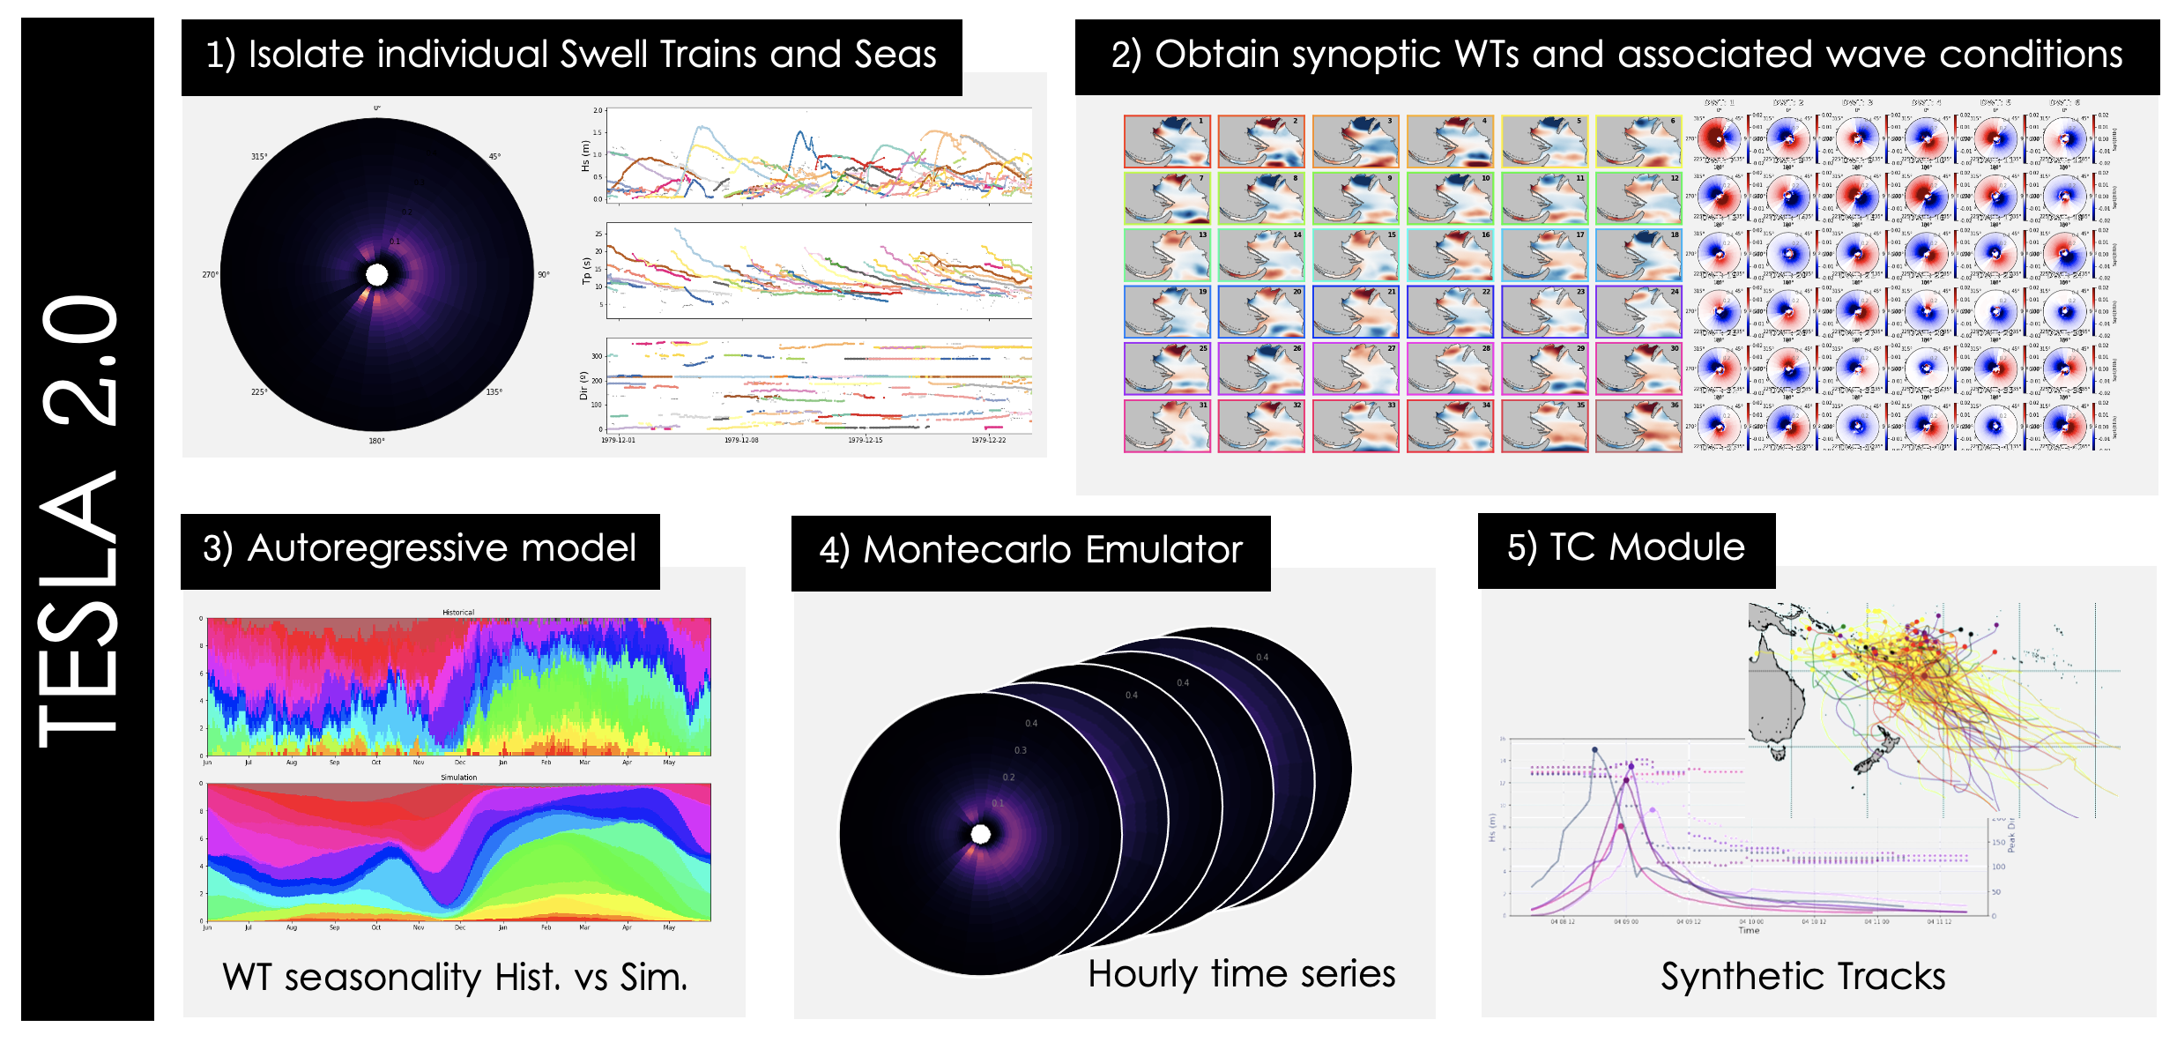
Figure 1. Methodology steps in TESLA 2.0

