Extreme Shoreline Erosion Analysis Using Monte Carlo Simulations

Yan Ding¹

¹ U.S. Army Engineer Research and Development Center, Coastal and Hydraulics Laboratory, 3909 Halls Ferry Road, Vicksburg, MS, USA. E-mail: Yan.Ding@USACE.ARMY.MIL

Abstract

Prediction of extreme shoreline erosion plays an important role in planning and management of coastal zones and regional sediment management. Quantifying uncertainties of shoreline evolution and risks of extreme shoreline changes (erosion and accretion) is a key task for practicing best shoreline protection. Due to complex natural features of offshore waves, sediment transport in alongshore and cross-shore directions, and sea level rise, prediction of long-term shoreline changes is a challenge.

This paper presents a probabilistic shoreline change prediction model to quantify uncertainties of shoreline changes in response to waves and sea level rise. A U.S. Army Corps of Engineers (USACE) shoreline evolution model, GenCade, is used to simulate shoreline changes driven by longshore and cross-shore sediment transport. Two types of probability density functions are developed to represent stochastic features of waves (i.e. heights, periods, and directions) under fair weather and extreme weather conditions. The capability of GenCade on shoreline retreat due to sea level rise is examined by predicting probabilities of shoreline change for an idealized coast using Monte Carlo simulation based on GenCade. Applicability of the model is also demonstrated by reproducing long-term shoreline changes at the coastal research facility in Duck, NC, USA. A maximum likelihood estimation is used to predict long-term extreme shoreline erosion (Fig. 1). Predicted uncertainties of long-term shoreline erosion can facilitate best engineering practice for design and management of shorelines and coasts.

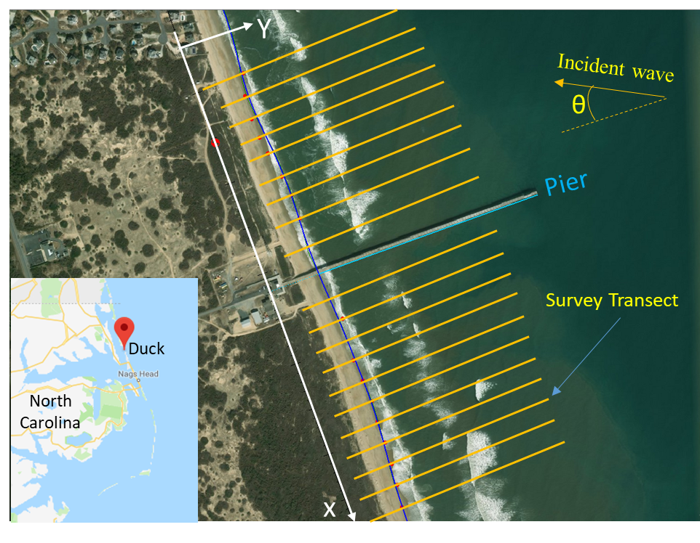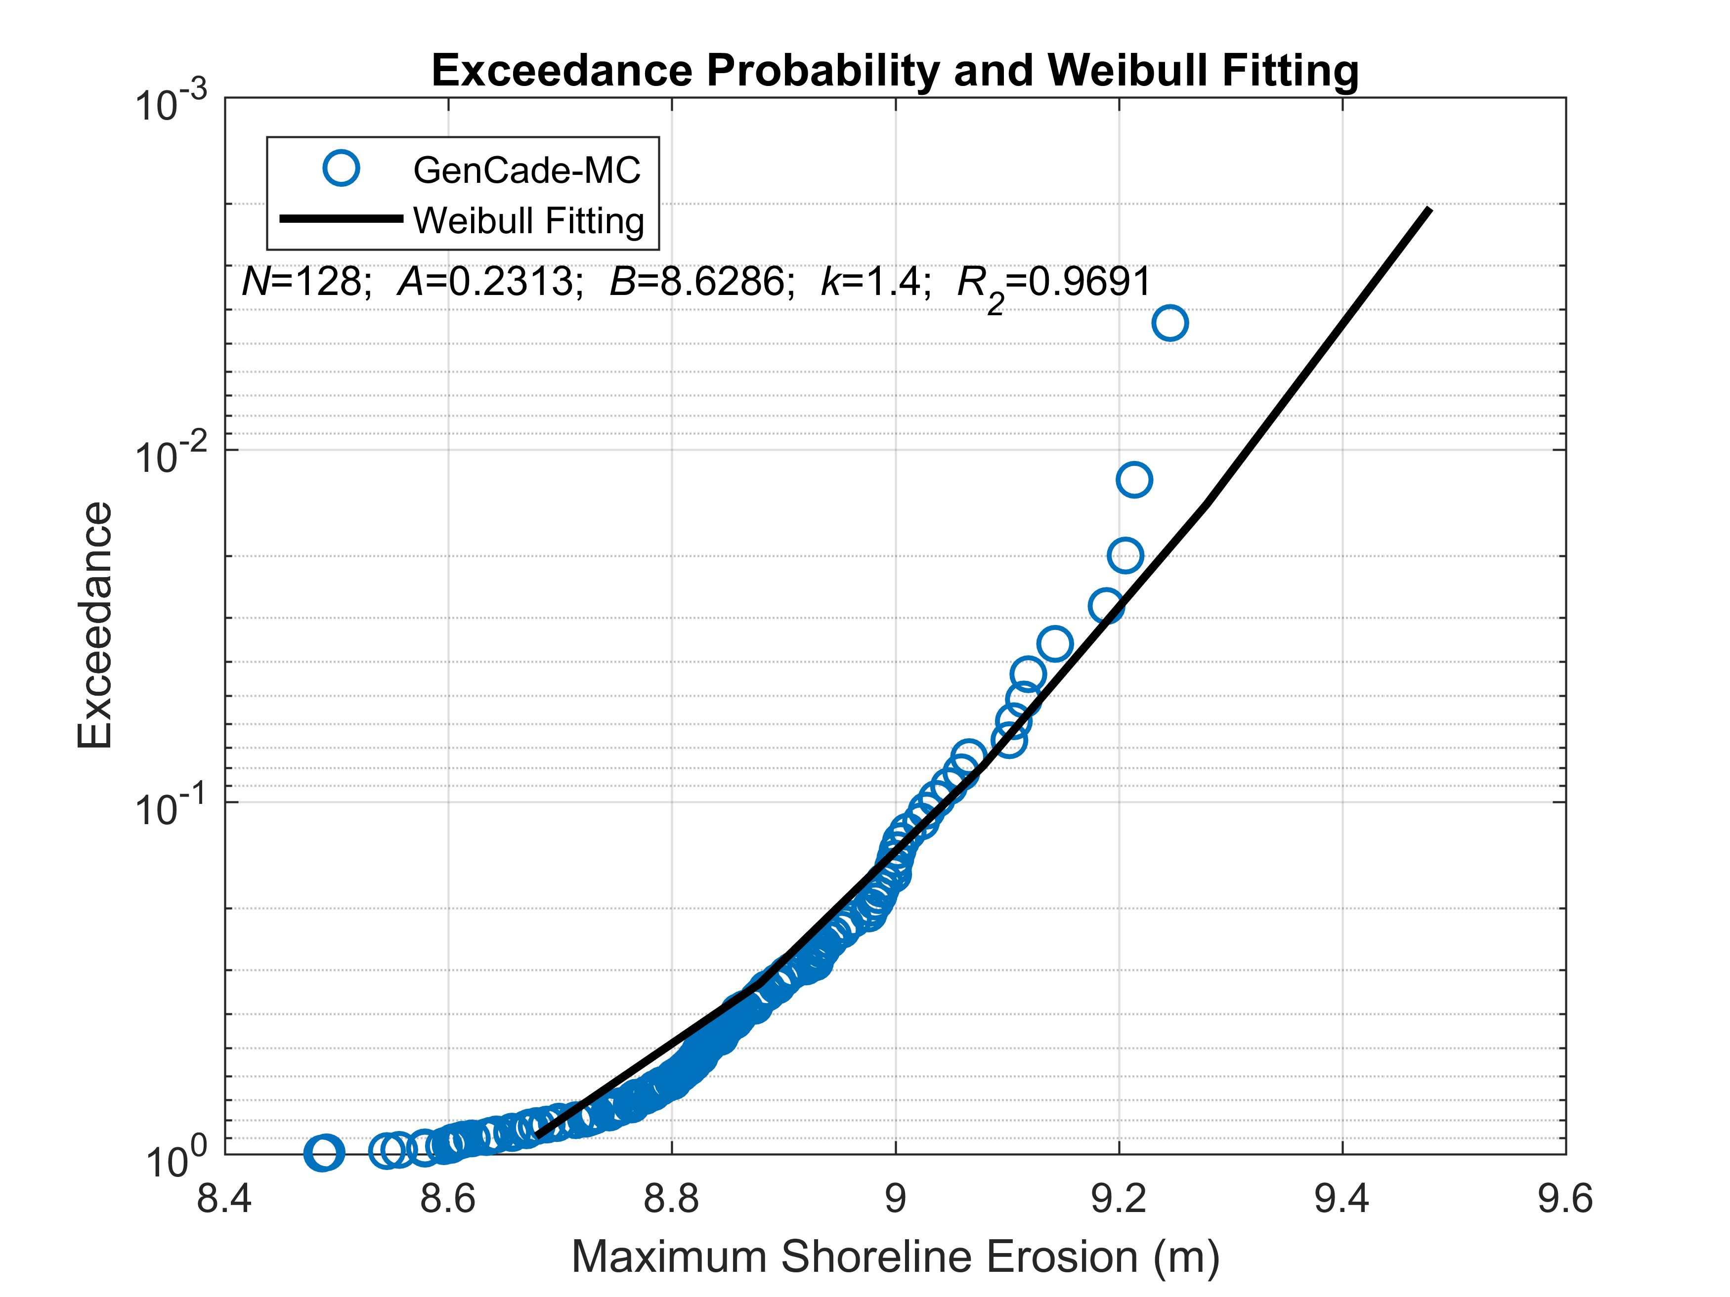
C
Fig. 1 Exceedance probability and a Weibull fitting for maximum shoreline erosion at the point C using the GenCade Monte-Carlo simulation results

