A probabilistic rainfall model to combat leading-edge erosion of wind turbine blades

Amrit Shankar Verma¹, Julie J.E. Teuwen²

¹Department of Mechanical Engineering, The University of Maine, Orono, ME 04473, USA
E-mail: amrit.verma@maine.edu
²Faculty of Aerospace Engineering, Delft University of Technology (TU Delft), 2628 CD Delft, The Netherlands E-mail: J.J.E.Teuwen@tudelft.nl

Abstract
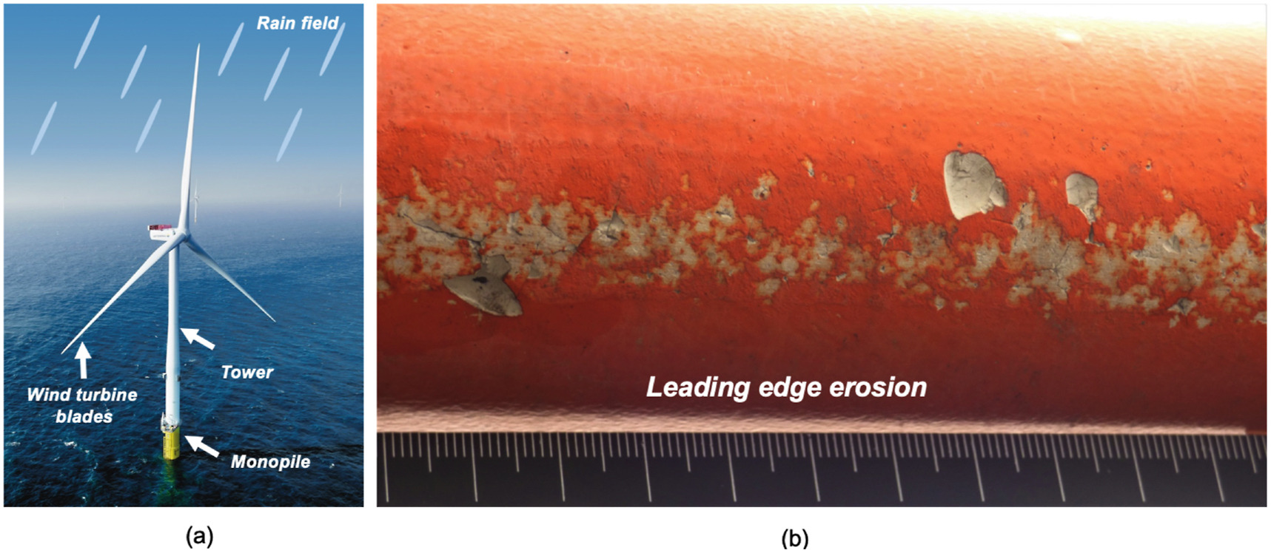
Recurring exposure of wind turbine blades to precipitation such as rainfall damages the leading edge of wind turbine blades referred to as leading-edge erosion (see Figure). The damage initiates with local pitting at the leading-edge surface, which further transpires into material loss causing local surface roughening, which hampers the aerodynamic efficiency of wind turbines. This decreases the turbine's power output while enhancing requirements of repair and maintenance activities, increasing energy costs, both for the onshore and offshore wind industry. Given this complex problem, it is essential to develop erosion models that can give a reliable estimate of the expected lifetime of the blade coating subjected to rainfall during their operations. One of the critical input parameters for such models is to estimate rain and wind loading on the blades, which is included by implementing rainfall and wind statistical characteristics for a wind turbine site. Currently, the wind industry utilizes standard rain droplet distribution, such as Best's distribution and Marshall-Palmer distribution, where representative droplet sizes (such as median droplet diameter) are chosen for varying rainfall intensities to calculate rain loading on blades. However, rainfall intensities and droplet size are statistically dependent, and rain loading must be ideally defined through their probabilistic joint distribution. The present study establishes a probabilistic rainfall statistics model that enables site-specific assessment of the blade lifetime where the probabilistic joint distribution of rain intensity and rain droplet size is combined with wind statistics for a given site. In this work, we also present a case study where the developed model is combined with a coating degradation model, and the expected lifetime of the blade coating is calculated for two different sites and a 10 MW wind turbine using a long-term probabilistic assessment.

The study found that the rainfall model evaluates the coating lifetime consistent with findings made in the literature – the expected life of the blade coating is three times lesser for the wind turbine operating at the coastal site than an inland site. Further, the results found using the developed model was consistent with the varying data periods (2 years to 50 years) used in the analysis. Finally, the model used in the study clearly shows the need for installing more disdrometers at existing and potential wind turbine sites in the future for reliable assessment of blade lifetime.

