Machine learning for coastal extreme storm surge predictions in New Zealand

Tausia J², Delaux S¹, Camus P², Rueda A², Bryan K³, Mendez FJ², Costa C¹, Perez J¹, Cofiño S⁴ and Zingfogel R⁵

¹Meteorological Service of New Zealand, New Zealand
²Geomatic and Oceanographic Engineering Group, University of Cantabria, Spain
³University of Waikato, Hamilton Waikato, New Zealand
⁴Department of applied mathematics and computer science, University of Cantabria, Spain
⁵Calypso science, New Plymouth, New Zealand

Abstract
Storm surge is the rise in water level generated by wind and atmospheric pressure changes associated with tropical or mid-latitude storms. In conjunction with tides, it is one major driver of coastal flooding associated with storm events. Because local inundation is strongly modulated by the local shape of the coastline and the bathymetric slope, accurate storm surge prediction by the mean of traditional numerical models requires the use of very fine grids and is hence very resource intensive. This means that the performance of a live prediction system based on such methods will likely be subject to a trade-off between prediction accuracy, prediction speed and cost. Thus, it is necessary to develop a statistical model able to reconstruct the extreme storm surge time series, given the atmospheric conditions, that performs as well as the numerical models, but improving the computational effort.
In this study, we explore different data driven methods to understand the relationship between atmospheric predictors and the behavior of extreme storm surge events (Figure 1). For the predictor we have relied on CFSR, and the storm surge is from the Moana Backbone Model, a recently released, 25-year regional hydrodynamic hindcast model by NZ MetService. We have first performed a regional atmospheric predictor clustering to characterize the extreme value distribution on homogenic subsets, and subsequently extrapolate extreme events at each hindcast node across NZ. Secondly, and after an exhaustive research for the best possible local atmospheric predictor, a reconstruction of these extreme values for the storm surge is carried out based on different non-linear methods.

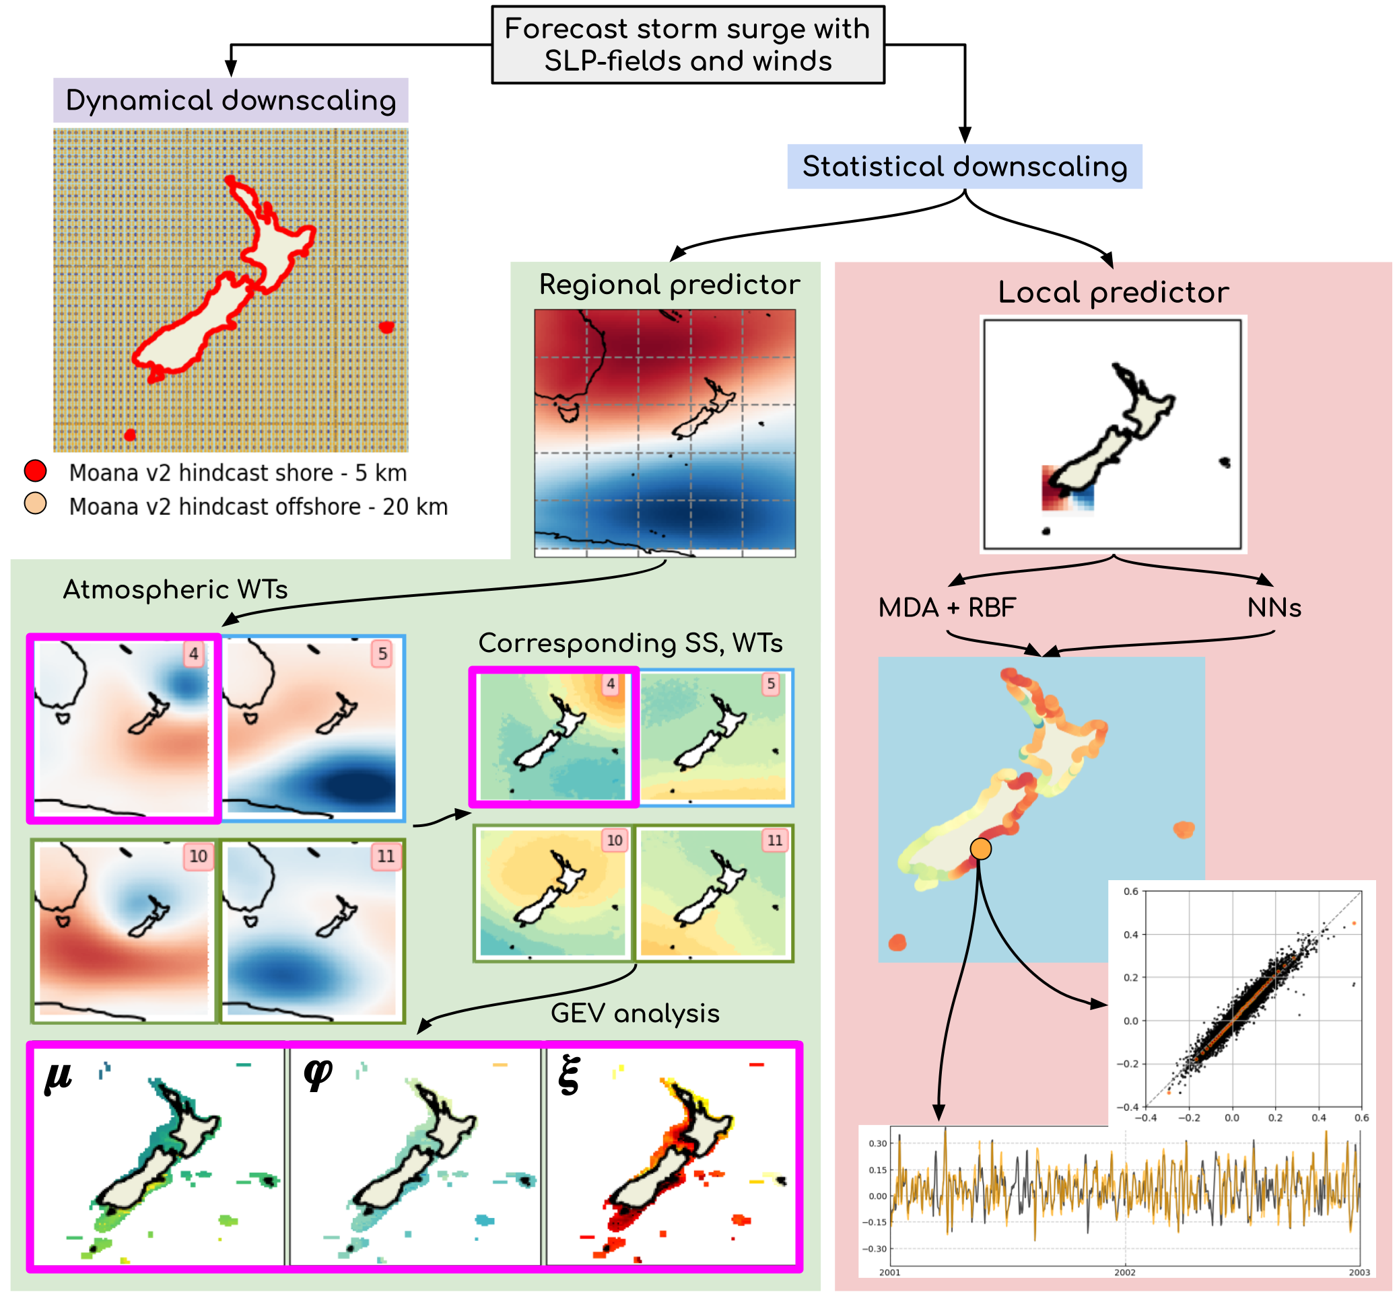

Figure 1. Methodology followed
in this study.

