A novel framework for capturing non-stationarity in extremal dependence structures

Callum Murphy-Barltrop¹, Jennifer Wadsworth²

¹STOR-i Centre for Doctoral Training, Lancaster University LA1 4YR, United Kingdom. E-mail: c.barltrop@lancaster.ac.uk

²Department of Mathematics and Statistics, Lancaster University LA1 4YR, United Kingdom

Abstract

In many practical environmental applications, it is important to evaluate the joint extremal risk from two or more variables. One method for quantifying this risk is through the so-called return curve, a risk measure which extends the concept of a return level to the general multivariate setting. Return curves represent contours of equal joint survival probability, and can be used as a general tool to summarise extremal dependence behavior. However, the variables of interest often exhibit non-stationarity: consequently, the vast majority of approaches for multivariate extremes, where data is assumed to be identically distributed, are not applicable in this setting. Moreover, for multivariate data, non-stationary trends often exist within marginal distributions and dependence structures simultaneously, resulting in complex data structures. Few approaches have been proposed for capturing such structures in the extremes literature to date.

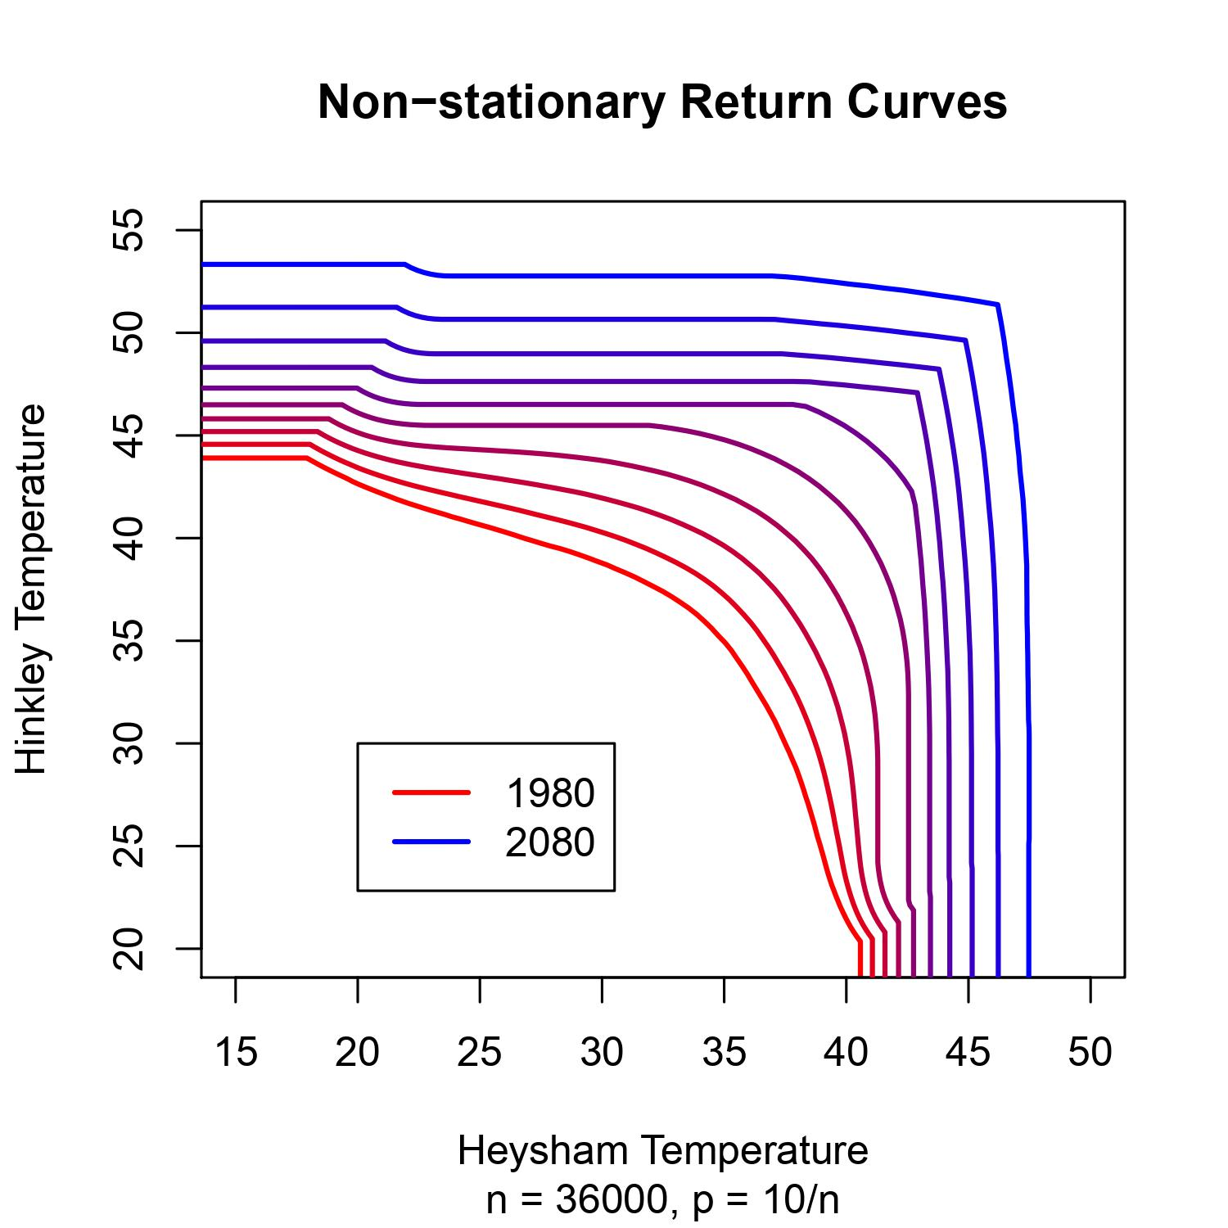
We propose a flexible semi-parametric modelling framework for capturing trends in extremal dependence. We show this framework is able to accurately capture a broad range of extremal dependence trends, leading to reliable return curve estimates. We also demonstrate our approach using temperature data from the UK Climate Projections from 1980-2080. Marginal trends are first accounted for via a pre-processing technique. Our model is then applied to estimate trends in the extremal dependence that are in good agreement with empirical evidence. Finally, the fitted model is used to obtain projected return curve estimates up to the year 2080, allowing analysis of the impact of climate change on joint extreme events.

